CLASS DIAGRAMS
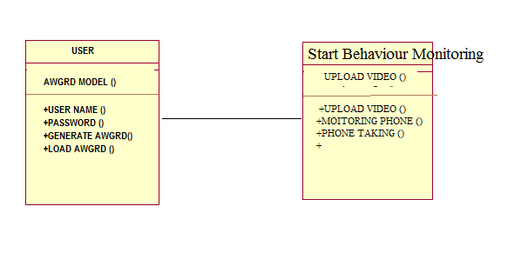

USE CASE DIAGRAMS

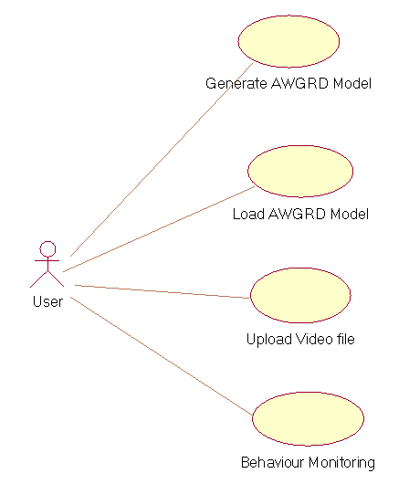
SEQUANCE DIAGRAMS
Collaboration Diagram

